**Assessment for Senior Data Analyst**

**Data Model for provided tables**

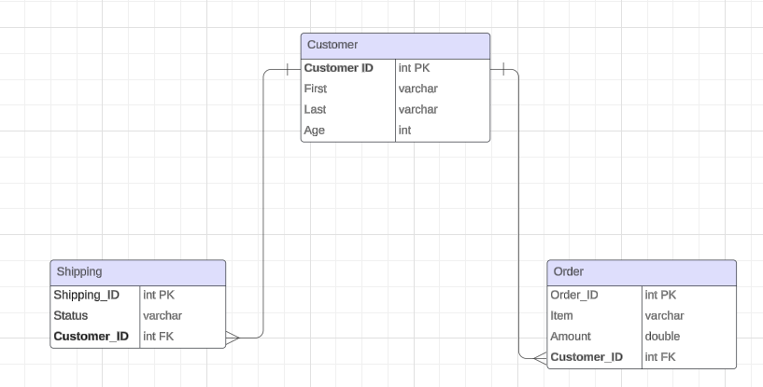

**Proposed Data Model**

**Merge Shipping table with order table for optimized data model**

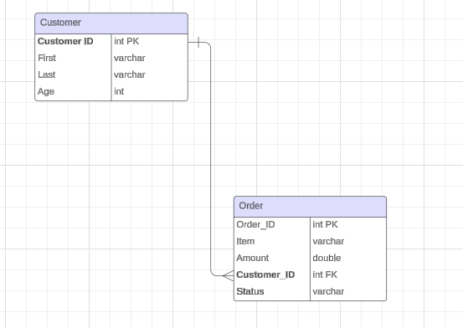

**Area of concern**

The above data model is proposed to avoid bi-directional relationship in Power BI (highlighted below). Bi-directional filters should be avoided to prevent any ambiguity in the dataset.

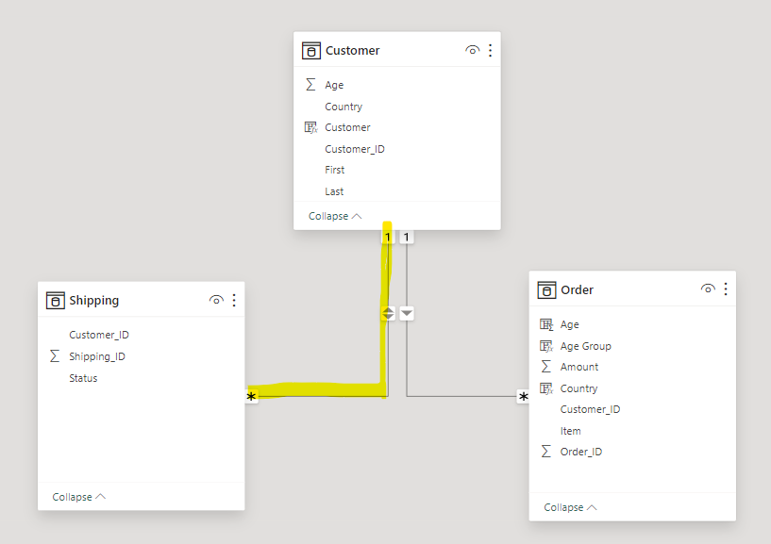

**Findings/Insights to Peer teams**

1. **Clean data by removing special characters from customer data.**
2. **Shipping table needs to merged with order data for optimized data model**
3. **Transactions data is not available. Transactions are calculated based on assumption that orders are transactions.**
4. **Also, as a suggestion, Order date, Shipping date and Delivery date can be added to the data model to provide more insights like “Shipped in Days” and “Delivered in Days”. Furthermore, it can be used to identify whether the delays are between order and shipping or Shipping and Delivery. This would help the organization to optimize their area of issue.**

**For Data Engineering team:**

1. **Data analyst to collaborate and confirm the accuracy and availability of transactions data with data engineering team.**
2. **Provide information about uncleaned customer data to remove special characters like “0”, “!” etc. from the data before loading it to reporting layer.**

**Insights to stakeholders**

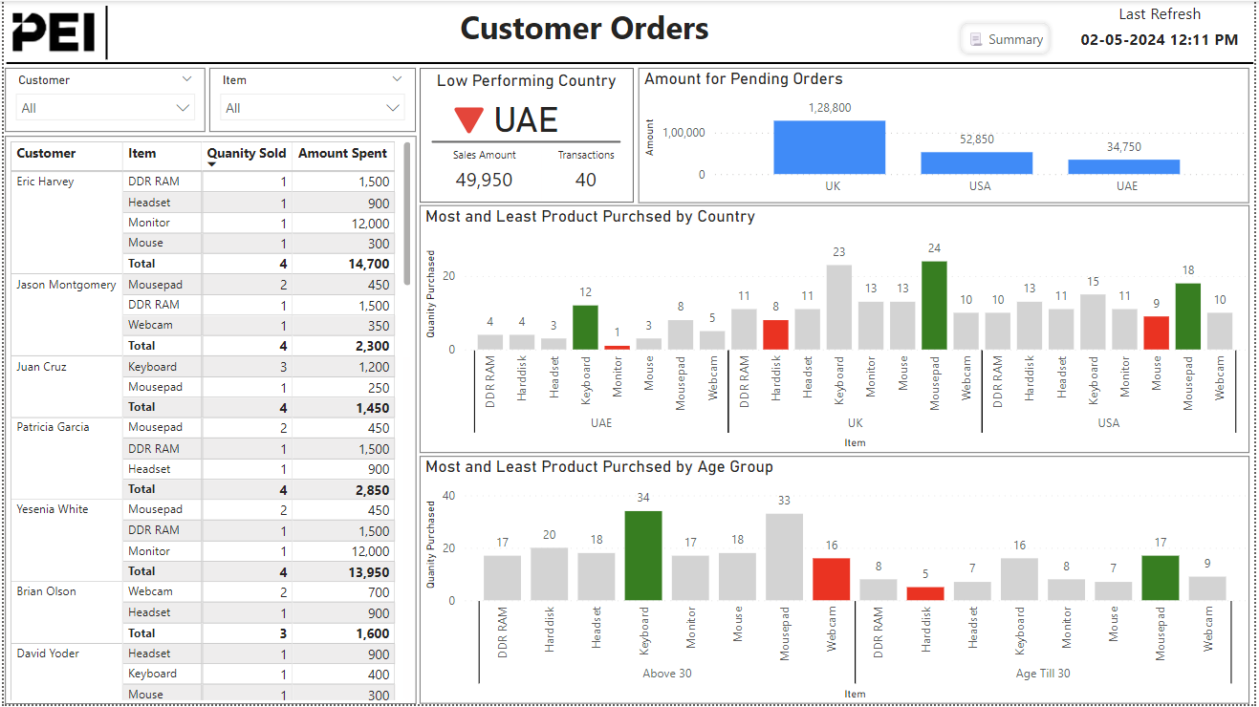

**Overall Summary**

**Summary button on top displays the summary of report. Click it again to hide the summary.**



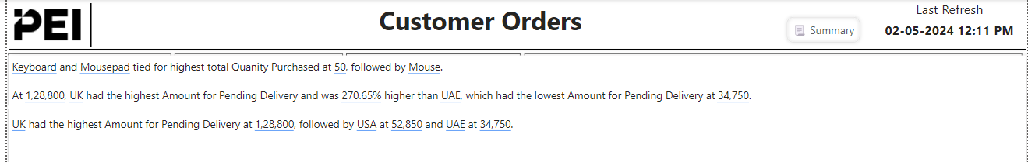

**You can also see summary at each visual level by clicking “Smart Narrative” icon on top right corner of each visual.**

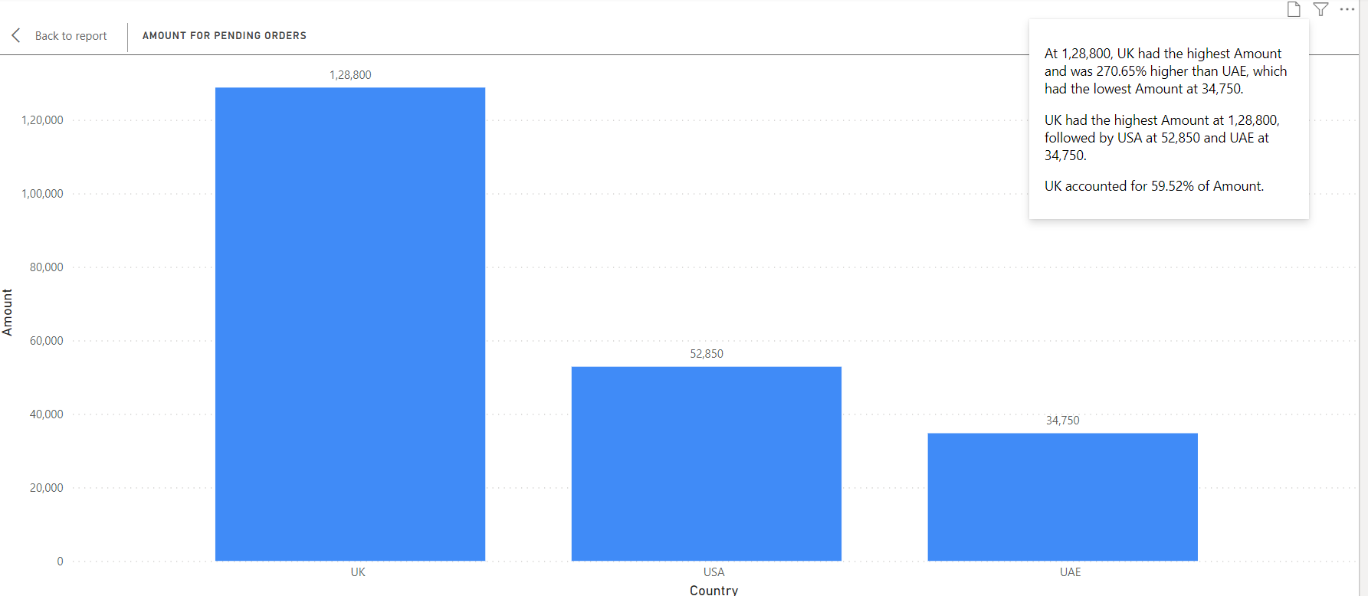

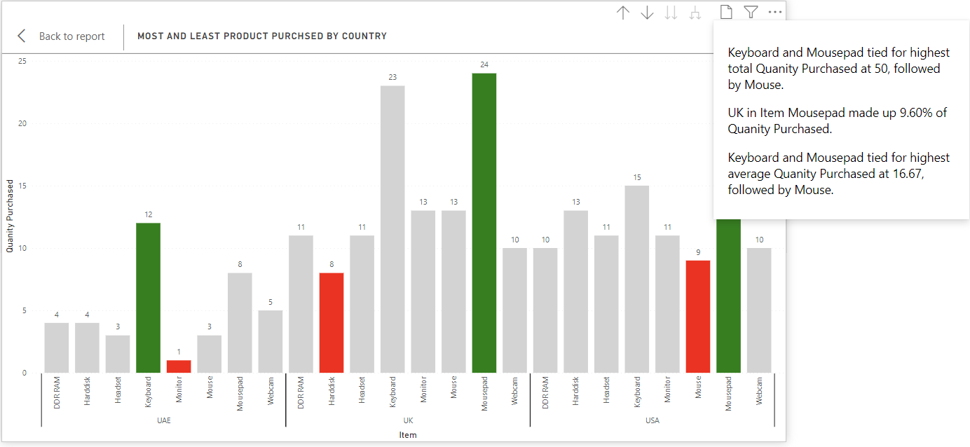

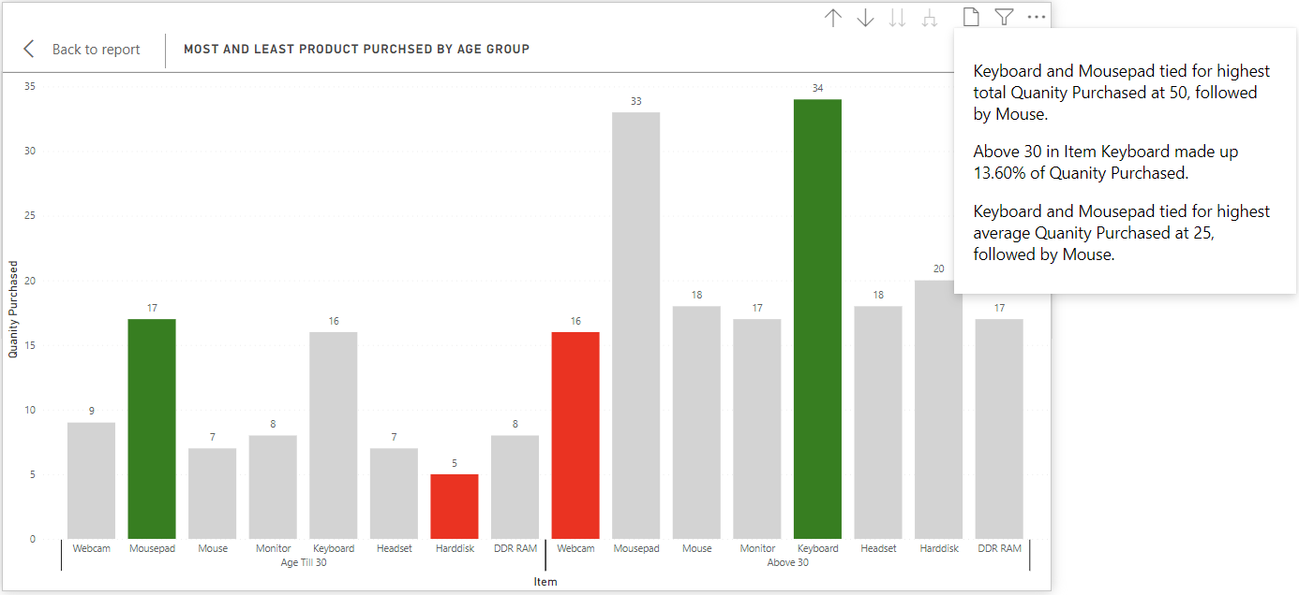

1. *the total amount spent and the country for the Pending delivery status for each country.*

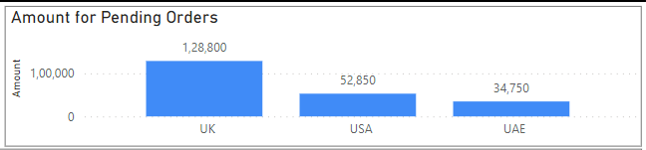

1. *the total number of transactions, total quantity sold, and total amount spent for each customer, along with the product details.*

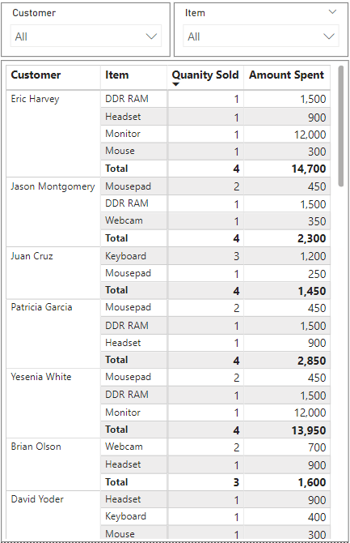

1. *the maximum product purchased for each country.*

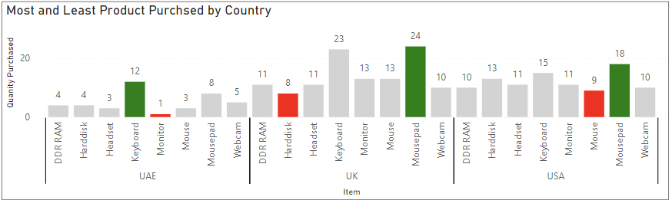

1. *the most purchased product based on the age category less than 30 and above 30.*

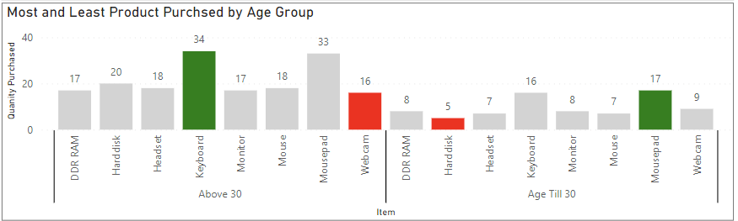

1. *the country that had minimum transactions and sales amount.*

